MarexMG

DCI Filter project proposal for ISS

By Miles Mann WF1F
www.marexmg.org

July 2, 2008

The DCI filter project is part of a complete Amateur Radio solution for ISS.

Why do we need a Dual band (2-Meters and 70-CM) RF filter for the Amateur radio station on ISS?

- When the commercial 143.xxx MHz transmitter is tested monthly, the Amateur radio station on 2-meters will go deaf for the duration of the test. The 2-meter station can not receive signals while the 143.xxx MHz transmitter is active. Fortunately this is only happening for short monthly tests. On at least one occasion the 143.xxx transmitter was left transmitting for most of a weekend.

- There were rumors that PC-Sat-2 may have caused undesirable RF interference to ISS receivers.

- There have been rumors that the RF emissions requirements for Amateur Radio equipment running on board ISS may become stricter in the near future.

- A good dual band filter will reduce the amount of terrestrial out-of-band interference being heard when using the Amateur Radio station.

The DCI Dual band filter can be used to solve all of these problems.

The DCI Filter:

The new Dual Band 2m/70cm filter is small and efficient.
It size is only W8" x D4" x H4" (inches) and weighs less than 2 kilos.

DCI can custom tune any filter we need to meet our requirements.

The existing “Off-the-shelf” solution is designed to work with today’s dual band transceivers, such as the Kenwood and other brands. One filter will provide Band pass filtering for both 2 meters and 70 cm, without changing cables.

If additional filtering is required, DCI can add small additional cavities to the existing filter to include options such as the 143.xxx MHz notch filter.

DCI has a proven track record of building and flying DCI filters for the Russian Space Station Mir.

Historical:

During the Russian Space Station Mir mission the commercial 143.xxx transmitter was used frequently. Every time the commercial transmitter was activated the Mir Kenwood TM-733 receiver would go Deaf until the 143 MHz transmitter shutdown.
The Receiver frequency for the TM-733 was on 145.985 MHz.

The temporary De-sensing problem was very frequent and would cause all of the expected problems.

- Packet mail connections would go into Time-out modes and users would be disconnected.
- Voice contacts were not possible. At least one school schedule in Texas failed because the NASA / Mir crewmember could not hear the school because the 143.xxx transmitter was active.

During Jerry Linenger Mir mission in 1997, I would occasionally setup Telephone patches between Mir and crewmembers families. On one occasion, the 143.xxx transmitter was active. I could hear Jerry calling strong and clear, however he could not hear my “Oscar” class satellite station until Mir was directly over my QTH. I was only able to punch through the interference for a few seconds with my 2400 watts of ERP. The phone patch was unsuccessful that day.

Solution:
DCI custom built a 2-meter filter with a special notch filter set for 143.xxx MHz. This filter was the first Joint ARISS Marex project in 1998. The filter was delivered by a Progress cargo rocket.

The 5 pound filter worked perfectly.
Now when the 143.xxx transmitter was active, the Amateur radio station on 145.985 would still function normally.

Approximate Specifications:

MODEL: DCI-145/435-DB

Description
Type: _________________Dual Bandpass Filter
No. of Poles:________________________4(x2)
Connector Type:________________________N

Mechanical Specifications
Physical Dimensions:_______W8" x D4" x H4"
Connector Spacing:_________________ 5.25"
Extrusion Size:________________________ 2"
Weight:__________________________3.5 lbs.
Mounting:____________________Stand Alone

Electrical Specifications

145 MHz
Center Frequency:________________145 MHz
Band Width:_______________________2 MHz
SWR:____________________________ <1.4:1
Return Loss:______________________>16 dB
Approximate 3 dB BW:_________ -/+ 1.6 MHz
Approximate 30 dB BW:______ - 3.7/+ 4 MHz
Approximate 50 dB BW:_____- 6.2/+ 7.7 MHz
Power Handling:___________ 200 Watts RMS
Impedance:_________________________50Ω
Temp. Drift:______ Approximately 2KHz /1ºC

435 MHz
Center Frequency:________________435 MHz
Band Width:______________________10 MHz
SWR:____________________________ <1.4:1
Return Loss:______________________>16 dB
Approximate 3 dB BW:___________-/+ 9 MHz
Approximate 30 dB BW:____- 17.5/+ 22 MHz
Approximate 50 dB BW:______- 28/+ 50 MHz
Power Handling:___________ 200 Watts RMS
Impedance:_________________________50Ω
Temp. Drift:______ Approximately 2KHz /1ºC

Actual plots from first Marex prototype (2 meter band)

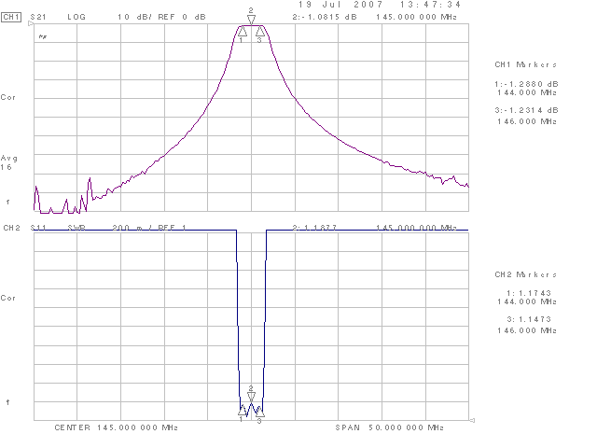
The frequency insursion loss for the whole ITU 2-meter bandwidth is less than 1.26 db across the band.
Frequency | Attenuation
185 | -80
175 | -72
165 | -60
155 | -40
145 | Less Than -2
135 | -42
125 | -60
115 | -75
105 | -90

Actual plots from first Marex prototype (70 cm Satellite band)

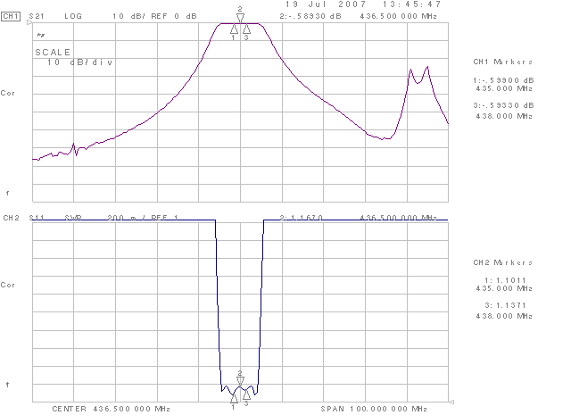

Frequency | Attenuation
485 | -35
465 | -60
455 | -42
445 | -20
435 | Less Than -2
425 | -22
415 | -50
405 | -64
395 | -70

