MarexMG David Clark Headset project proposal for ISS

By Miles Mann WF1F
www.marexmg.org

July 2, 2008

The Ericcson HT project currently on board ISS is designed to use the commercial grade headsets from the company David Clark. The Ericcson / David Clark combination was in use on ISS for over 5 years of reliable service. The DC Company is known world wide for designing high quality commercial grade headsets, which are commonly used in the aviation industry.

It has been suggested by one of the ARISS team members that future amateur radio products on ISS also included DC headsets as part of their configuration. The Kenwood TM-D700 on ISS does not currently support the DC headset. This option can be easily corrected.

Goal:
Design a headset that can be used with the Amateur Radio station on ISS. The purpose of the headset is so the crew can have a quite conversation the amateur radio station.
- Audio from the transceiver will be directed to the Ear-cups at a volume level comfortable for the crewmember.
- Audio from the boom microphone will be sent over the air and at the same time, the noise caused from the 100+ fans running in the background of ISS will be significantly reduced.
- At any time the ISS crew can unplug the headset and switch over to the stock hand microphone.

Status:
A pair of custom designed a headset adapters have been built for the Kenwood TM-D700 and the Icom ID-800. For the rest of this article I will refer to the Kenwood TM-D700 as the “D700” and the Icom ID-800 as the “ID-800”. This portion of the project has already been completed and I now have two engineering prototype modules that will allow the users to connect a DC headset Model number H3432 (P/N 40524G-02) directly to the Kenwood D700. Due to completely different microphone pin requirements between the Icom and Kenwood, two different adapter modules were developed.

Adapters:
The adapters plug in to the Speaker port on the transceivers using a stock connector and feed audio into the passive noise canceling ear-cups. The Microphone cable uses a standard RJ-45 8-Pin connector that plugs directly into the transceiver. There is a small adapter box in-between the headset and the transceiver. The adapter box has a simple Push-to-Talk switch mounted on the side of the box. On the end of the adapter box is a standard headset connector port designed to accept the headset connection. There is also a volume knob on the adapter box.

The adapter box is self-powered, which means it gets is power directly from the transceiver over the stock microphone connections. You do not need to perform any modifications to any of the transceivers.

Headsets:
The headsets that we are currently testing with are the model H3432. This model provides excellent passive noise canceling for both the Microphone element and the ear-cups. For this project I recommend using the Passive Noise canceling headset system verses the Active Noise canceling system. I am confident the passive system will meet all of our noise canceling needs without using the Active systems. The active systems are more complex and will require additional circuitry and power needs.

Keep It Simple, Benefits:
The existing D700 or proposed ID-800 transceivers do not need any modifications to use the DC headset system.
The Headset Model H3432 is a stock off the shelf headset. You do not need to modify any of the components of the headset.
The Adapter Boxes will make all of the level adjustments required to match the transceivers to the headsets.

Initial On-the-Air testing:
The results from testing both the Icom and Kenwood versions of the DC system have been very encouraging. Most people can not tell I am using a noise canceling microphone system.

During one test, I used a 5000 BTU window style air-conditioning system to simulate loud fan noise. With the air-conditioning system running full blast and the boom microphone placed 2 inches from the AC exhaust duct, the listeners could not tell the AC was running.

Project Images

Adapter Box, Top View

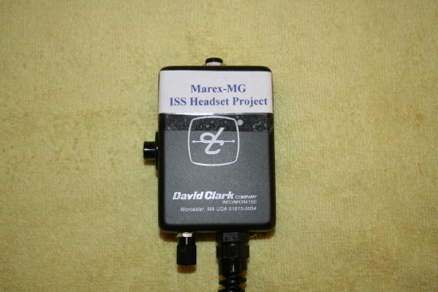

Adapter box, with Headset connector, PTT switch and Volume controls.
Adapter Box, Volume knob View

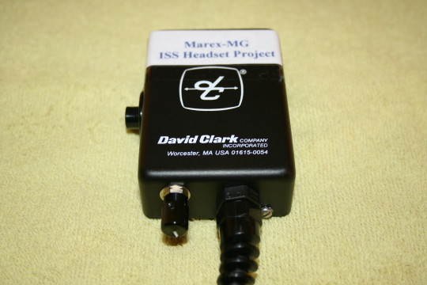

Close up of the Volume control knob.

Adapter Box, PTT view

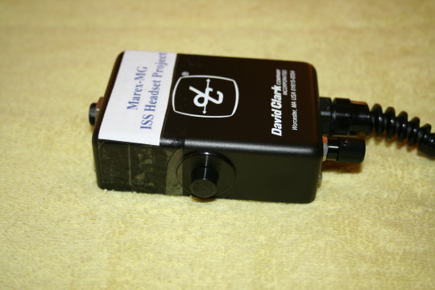

Close up of the PTT switch.

Pin Adapter view

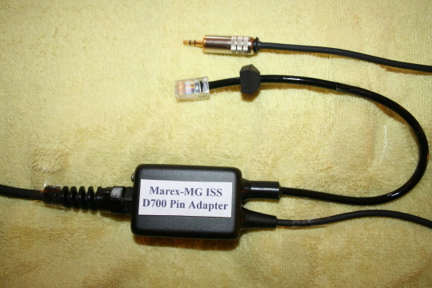

Kenwood TM-D700 microphone pin adapter box. The top connector is for audio from the radio to the Ear cups. The RJ-45 connector plugs directly into the D700 microphone port.

Full Adapter View

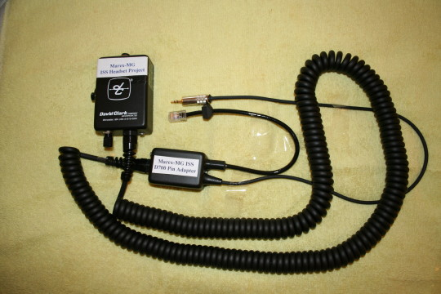

Full view of the whole adapter system.

International Space Station Amateur Radio Project Images for the Ericcson DC system.

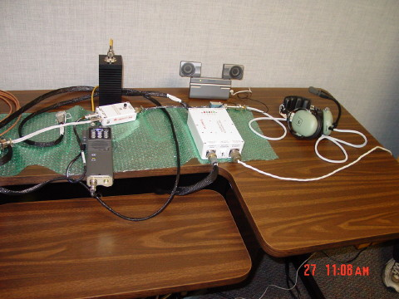

Pre flight images of the Ericcson transceiver system with a David Clark headset. In this system, major modifications were performed to the Guts of the DC headset. With the Marex proposals, we will not need to modify any of the internal components of the DC headset. Note: For flight safety reasons, it may be required to replace the cables with flight qualified cables. This task should be very simple, since the 3 connectors used in the system are all stock connectors that are commonly available.

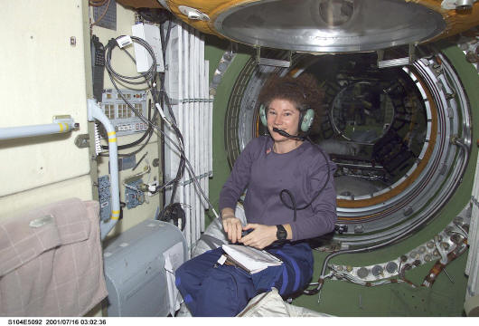
July 2001, Susan Helms using the Ericcson transceiver and wearing the David Clark headset. The Ericcson transceiver is velcroed to the wall next to the coil of gray cables, just above the top of the handrail.

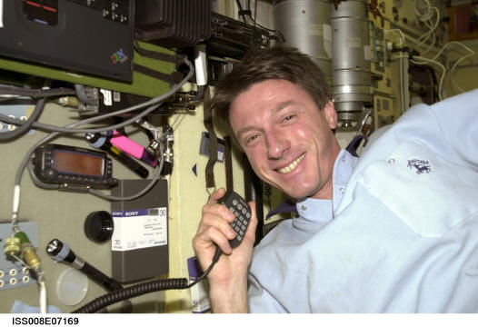
December 8, 2003
Astronaut C. Michael Foale, Expedition 8 mission commander. Testing out the new Kenwood D700 ISS-Amateur Radio station from the Zvezda Service Module on the International Space Station (ISS). The proposed project would allow the crew to use either the Stock microphone or a DC headset. The D700 radio can be see just poking out from under the green table and the orange display head is velcroed to the wall.

