From: Miles Mann WF1F, CEO MaresMG

Version 1.01 August 15, 2009

Project:

USB Laptop to Kenwood Interface Project

This project was submitted to the ARISS Project Selection committee in April 2009. The project was rejected because ARISS now has a new Members only policy and has created a monopoly controlling all Amateur Radio projects submitted to the International Space Station.

I consider the Monopolistic actions of ARISS to be Illegal under the laws of the United States.

I believe that NASA, ESA and RSA should sever all relations with the Monopoly ARISS and give the world back access to the Amateur Radio projects on ISS.

April 2009
Memo from Gaston Bertels, ON4WF ARISS Chairman
To Miles Mann, MarexMG

USA member societies are the ARRL and AMSAT NA.
Only these societies can nominate participants to the ARISS-i meetings.

***

Questions proposals need to address

Name of organization with a brief description of organizations activities

MarexMG 503.C Non Profit Organization.
This means we can legally accept donations.

At MarexMG, We specialize in trying to keep manned amateur radio projects fun and affordable.
To date we have delivered 4 successful projects into space for manned space flights.

Mir Space station.
Slow Scan TV
Kantronics Packet Mail
DCI RF Filter project

ISS
SpaceCam1 Slow Scan TV
Ongoing support for Packet projects.

Detailed description of Project including length of time needed to develop

Marex USB VOX box interface (SignaLink-USB)

The Problem:
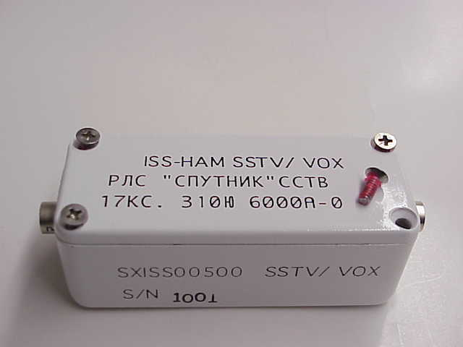
The existing Laptop to Radio interface on ISS is called “ISS-HAM SSTV/VOX”, part number SXISS00500.

The goal of this device was to provide a reliable Audio/Voice activated control signal from a laptop to enable the transceiver/radio to turn on and off by sound control. The current implementation of this device does not work correctly. The “ISS-HAM SSTV/VOX” unit causes the transceiver / radio to get stuck in the transmission mode.

The ARISS team is aware of the problem and has flown a second “ISS-HAM SSTV/VOX” unit to ISS. The second unit has the same stuck transmitter problem. Once the Laptop software tells the Kenwood TM-D700 to transmit, the TM-D700 will continue transmitting and will not turn off until the built-in Watchdog timer commands the D700 to switch back to receive.

This problem causes excessive thermal loads on D700 transceiver and has prevented us from using the laptop applications such as SpaceCam1 to their fullest extent.

What caused the problem?
After a close examination of the schematic for the “ISS-HAM SSTV/VOX”, it is possible that the lack of RF de-coupling on the DC power line maybe causing excess RF to effect the circuit.
The “ISS-HAM SSTV/VOX” gets its power from inside the D700 radio. When the D700 transmitter is commanded ON, the RF coming down the DC line from the D700 maybe effecting the bias of the Opamp and forcing a Stuck On transmitter condition.

Marex Solution:
Marex proposes to replace the exiting “ISS-HAM SSTV/VOX” with a Consumer-Off-The-Shelf solution called SignaLink-USB.

Marex had been testing the SignaLink-USB for over a year. We are very pleased with the performance of the new laptop VOX solution. We prefer to use COTS hardware whenever possible.
In this case the SignaLink Company has sold over 5,000+ of the SignaLink-USB around the world in just 2 years. The SignaLink-USB has proven its ability to work on many different types of radios and has a proven track record of reliability.

The SignaLink-USB project goals:

- Provide a stable Computer to Radio Interface.
- Enhance the performance of the existing SSTV SpaceCam project on ISS.
- Enhance the ability of the Laptop to be used for additional Amateur Radio projects.
- Simplify the hardware and cable connections between Transceivers and Laptop (The s SignaLink-USB uses stock USB and CAT-5 cables, special cables are not required).
- Transceiver modifications will not be required.
- Use the USB on the Laptop to provide filtered power to the new SignaLink-USB
- Replace the exiting ISS-HAM SSTV/VOX system, which has problems with locking the transmitter in the ON State. 5k

Testing:
The SignaLink-USB has been extensively tested with the Kenwood TM-D700 transceiver, running SpaceCam1 software. We have not noticed any problems. The quality of SSTV images is excellent.

Benefits:
The SignaLink-USB is true Off-the-shelf technology. The hardware is ready today. We will not have to wait 3-5 years for untested hardware to be designed, developed, debugged, tested and documented. MarexMG can deliver the Replacement hardware faster than you can do the paper work.
The SignaLink-USB solution can be ready for flight in 2009.

Hardware Images:

Front View:

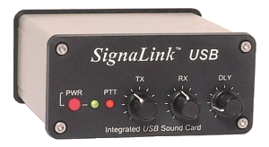
This view shows the easy to use control knobs.

Rear View:
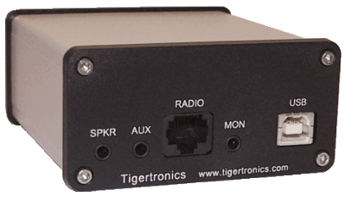

Rear View, shows you the 5 standard connections.
For the Kenwood project, only the RADIO and the USB connectors will be used.

Circuit Board:

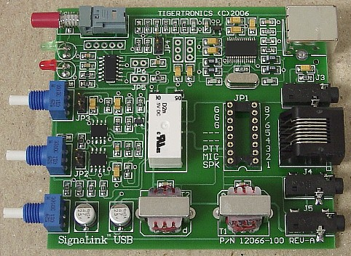
Inside view of the circuit board

Supporting Links

http://www.tigertronics.com/files/slusbqstreview.pdf

Estimate of funding including the expected source of funding

Most of our funding comes from individuals and corporations. The costs will depend on the number of units required for testing. We can expect some support from the selected manufactures and the rest from the Amateur Radio community.

Proposed certification procedure for the project

Since the hardware is Off-the-Shelf, we will use existing certification documentation generated by the manufacturer of the SignaLink-USB.
All electronics sold in the USA needs to pass FCC Class A and Class B RF Emissions testing; we will use existing manufactures documentation as part of the certification process.

Preliminary block diagram and sketches of the project

TBD

Questions proposals need to address cont.

What involvement will the crew have in the project (development, deployment, set up and operation)?

The SignaLink-USB unit uses existing software, which is part of the Windows 2000, and XP operation systems. The SignaLink-USB does not require any software installation. This will significantly simply the installation of the SignaLink-USB.
The SignaLink-USB uses stock USB and CAT-5 cables for it connections (If the microphone port is not going to be connected to the SignaLink-USB, we will need to make a DIN cable for the data port on the D700).

USB Laptop Interface project:

The SignaLink-USB interface will support the following:
- Push to Transmit
- Audio Input and Outputs.
- This will allow ARISS to develop software based amateur radio programs that will utilize the Amateur Radio transceiver and laptop capabilities, such as SpaceCam1 Slow Scan TV and other applications.

Development:
The SignaLink-USB Laptop Interface is a Consumer-Off-the-shelf device.
No development time will be required.

Deployment:
The initial setup for a project such as SpaceCam would be 1 hour or less.

Setup and Operation:
After the initial setup, operation will be very basic and instructions associated with each
software project, such as SpaceCam1 SSTV.

Specifications SignaLink-USB:

Power Supply: USB Port Powered

Audio Freq Response: 100Hz - 10Khz**
**Upper frequency response is intentionally
limited by Low Pass Filter.

Sampling Size/Rate: 16 Bits, All standard rates are supported up to 48Khz

Computer OS: Windows 98SE, ME, 2000, XP & Vista
MAC OS 9.1 or later
MAC OS X 10.00 or later
Linux

Computer Hardware: This depends on the program that you are running
(see your program's Help or ReadMe file for details).
Most communications programs run fine on a 266Mhz
or faster Pentium type processor, but some may require
a faster computer.

Radio In/Out Z: 600 Ohm (nom). TX/RX Levels are fully adjustable for
compatibility with Hi-Z and Low-Z radio connections.

Auto-PTT™ Delay: Adjustable "Hang Time", 30 ms to 3 seconds

PTT Circuit: Relay, Rating - 3AMP (max)

Radio Connector: TX Audio, RX Audio, PTT, GND - RJ-45
RX Audio/Speaker - 3.5mm Mono

Computer Connector: USB 1.1/2.0 Compatible
Standard USB "A" type connector

Other Connectors: Aux. Speaker - 3.5mm Mono

Case: Extruded Aluminum - 6061T4

Dimensions: 1.6" x 3.2" x 3.6"

Operating Temp: -30C to +60C

**Specifications are subject to change without notice. Tigertronics reserves the right to change specifications to improve our products, or for any other reasons that we deem necessary.

What facilities or support is required for this project including ISS support (example a computer, power-cooling etc.) and ground support (example downloading of mail, downloading files, uploading files etc.) ?

The goal is to replace the existing ISS-HAM SSTV/VOX unit with the new SignaLink-USB. A new set of adapter cables will be provided (if needed). The SignaLink-USB uses standard cables, which may already on ISS. Custom cables may not required.

- USB Cable A-Type Plug and B-Type plug.
- CAT-5: Standard straight through 8 pin CAT-5 or CAT-6 cable.
- DIN to CAT-5 if D700 Data port is used.

ISS Support:
The SpaceCam1 Slow Scan TV will require a Laptop.
Crew training will need to include teaching the ISS crew how to load images onto a Laptop from one of the many digital cameras on board ISS.

We will need Support from ARISS to verify the hardware is flight qualified.

What is the specific educational outreach purpose of the project and how will that be implemented?

The best bang for the buck project is the existing SpaceCam1 project. This project will stream 400 JPG images per day from ISS. The images will be seen around the world and will be reprinted on Newspapers and TV news around the world. The SpaceCam project will re-energize interested in Amateur Radio Satellite activities. What this project needs is a stable Amateur Radio station on ISS. The current Amateur Radio station is not reliable enough to be used for SpaceCam. The new system I am proposing will meet all of our goals.

How will the Amateur Radio Community benefit from the project?

This system combined with SpaceCam1 will inject excitement into the Amateur Radio community world wide. It will show the world that Amateur Radio Satellite is affordable and easy to use. These projects will reach more than just the 2 million amateur radio operators; they will cross over and reach into the 10 of millions of Shot-Wave-Listeners that will be now able to monitor the streams of images coming from ISS.

School systems around the world will setup simple VHF receiving system and let their computers monitor the down link frequencies from ISS for a daily download of images. The whole world will learn more about the Amateur Radio community and our ability to blend our projects into affordable Space exploration.

Questions proposals need to address cont.

If the proposal is to fix a perceived problem, What is the problem and what happens if we do nothing. What are the alternatives to this proposal.

The existing Laptop to Radio interface on ISS is called “ISS-HAM SSTV/VOX”, part number SXISS00500.

The goal of this device was to provide a reliable Audio/Voice activated control signal from a laptop to enable the transceiver/radio to turn on and off by sound control. The current implementation of this device does not work correctly. The “ISS-HAM SSTV/VOX” unit causes the transceiver / radio to get stuck in the transmission mode.

The ARISS team is aware of the problem and has flown a second “ISS-HAM SSTV/VOX” unit to ISS. The second unit has the same problem. Once the Laptop software tells the Kenwood TM-D700 to transmit, the D700 will continue transmitting and will not turn off until the built-in Watchdog timer commands the D700 to switch back to receive.

This problem causes excessive thermal loads on D700 transceiver and has prevented us from using the laptop accp9icstons such as SpaceCam1 to their fullest extent.

What caused the problem?
After a close examination of the schematic for the “ISS-HAM SSTV/VOX”, it is possible that the lack of RF de-coupling on the DC power line maybe causing excess RF to effect the circuit.
The “ISS-HAM SSTV/VOX” gets its power from inside the D700 radio. When the D700 transmitter is commanded ON, the RF coming down the DC line from the D700 maybe effecting the bias of the Opamp and forcing a Stuck On condition.

What Amateur Radio frequencies will the project utilize?

These projects can operate on the same frequencies which that are currently being used by ISS in accordance with the ITU Amateur Radio satellite band. 2-meters (144-146 MHz) and 70-cm (435-438 MHz)

Any other comments that will help the Committee evaluate this project.

Additional Criteria For Proposals

Equipment must be capable of operating unattended for extended periods (weeks).

Marex has performed extensive tests with the SpaceCam1 software. The SpaceCam1 software running on Windows XP has been stress tested for 9 full months of unattended Running operations in Repeater mode.

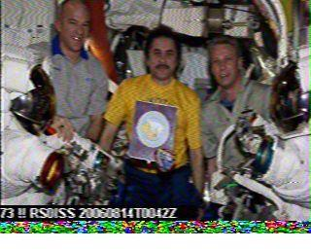
(Actual picture from ISS via Marex SpaceCam1)

With proper air ventilation and fan cooling the Icom transceivers should run for 3-5 years or more. The Turbo Fan add-on heat sinks will help compensate for Zero gravity and keep the radio cooler.

Equipment should be designed to power on into the default state. A reset of the Equipment must restore it to a desired default state.

Crew interfaces must be very simple .

This is one of our main goals. Keep It Simple

Procedures must be provided for equipment operation prior to being approved for flight.

SpaceCam1:
The procedures and manuals have already been developed and are currently on ISS.

Systems capable of being controlled from the ground will be given preference.

There is no assurance that equipment will be returned or brought back down.

The purpose of the equipment is to provide many hours of educational usages on board ISS. To be successful is the major criteria, rather than having the equipment returned to Earth.

My first three projects on the Russian Space Station Mir all burned up.
However they had many hundreds of hours of successful usage before their retirement.



Including Marex Projects:

Project flow and activated on the Russian Space Station Mir

- Kenwood TM-733 (In flight support)
- Kenwood TM-V7A (SSTV System)
- Tasco SSTV System
- Kantronics KPC-9612 (Design, Deliver and Remote control)
- DCI RF Filter

Project flow and activated on the International Space Station

- SpaceCam1 Slow Scan TV (Activated August 2006 and October 2008)
- Kenwood TM-D700 (Software simplification project 2008. MarexMG team convinced ARISS to fix some of the configuration issues with the D700. We also tested the configuration settings and confirmed they solved the Mail box and delay problems. Unfortunately the software has not been uploaded to the D700 on ISS)
- Suit-Sat-1 (The SSTV Image used by Suit-Stat-1 was generated by SpaceCam1. The audio portion of the SSTV image was saved in an audio file on Suit-Stat-1 and played back once every 9 minutes.)
Cabling Images, Laptop to D700 via SignaLink-USB

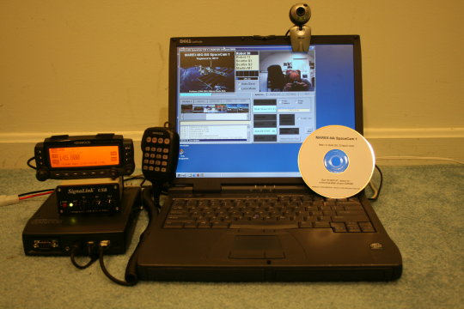
Full System image.

From Left Bottom, Kenwood TM-D700 transceiver.
SignaLink-USB Vox replacement module.
Display head for the TM-D700 transceiver.
Microphone.
Laptop running SpaceCam1 with a USB video camera.

All of this hardware is currently on ISS with the exception of the SignaLink-USB Vox module.

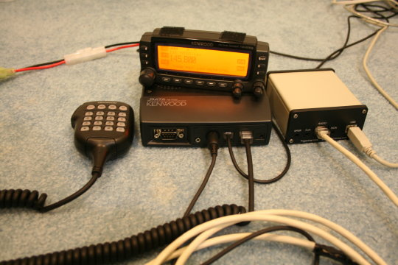
This image shows the typical Kenwood TM-D700 and USB connections.

From left front of Kenwood TM-D700
Data Port to SignaLink-USB (New Cable)
RJ-12 port to Display head (Existing Cable)
RJ-45 port to Microphone (Existing Cable)

From Left rear of the SignaLink-USB Vox
RJ-45 port to D700
USB cable to Laptop (Stock cable)

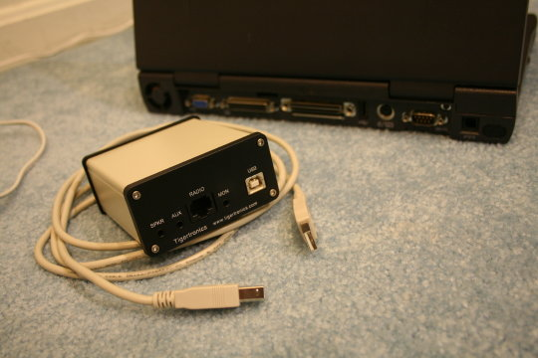
Close-up of the SignaLink-USB Vox device with stock USB cable

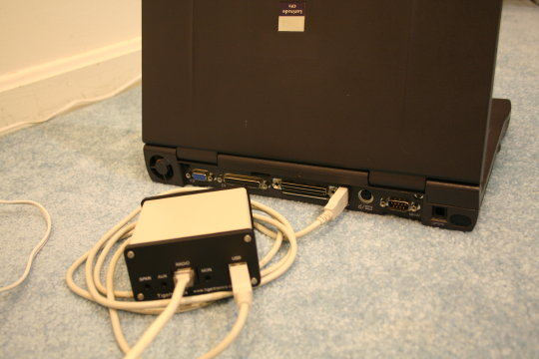
SignaLink-USB Vox connected to the laptop USB port and the RJ-45 cable connected to the TM-D700

